Windows 98 IR setup for IR220L/220L+/210L/200L

Caution: To install this SIR driver in Windows98, please be sure no FIR driver was installed first. If the FIR driver was already installed, even you remove this FIR driver and then install SIR driver, it may not work properly.
*Do not install Infrared Driver Ver 2.0 under Windows98, it will not work at all.

Connect ACT-IR2xxL serial adapter to the Com port of desktop PC. If there is no IR window on the portable PC, another IR2xxL should be connected to the portable PC.
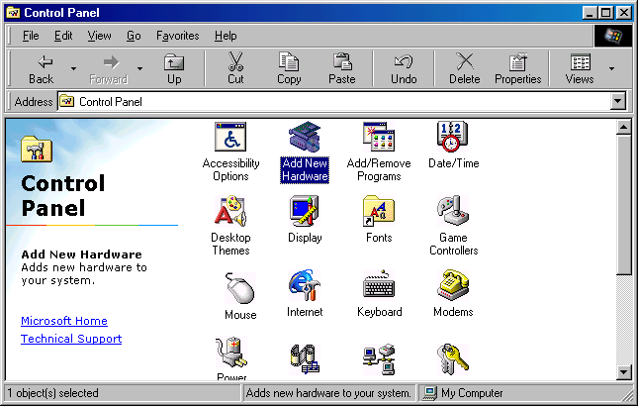
- Go to “Control Panel” and double
click on “Add New Hardware”.

- On the following screens, click on “Next” twice, then select “No, the
device isn’t in the list”. And click on “next”.

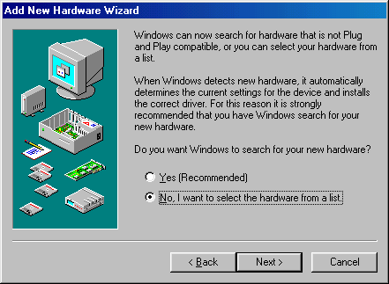
- Select “No I want to select
Hardware from the list”,

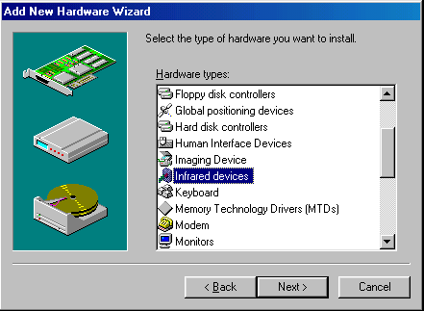
- Scroll down the menu and
highlight “Infrared Devices”,
then click on “Next” twice.

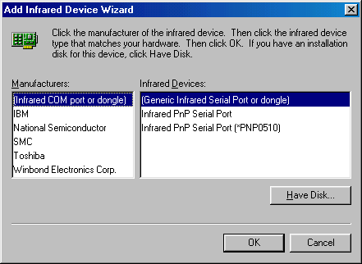
- Under “Manufacturers” Select
“(Infrared COM port or dongle)”,
and then in “Infrared Devices”
Select “(Generic Infrared Serial Port
or dongle)”.

Click on “OK”.

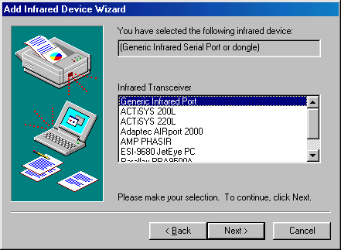
- At “Infrared Transceiver”, Select “ACTiSYS IR-220L or ACTiSYS IR-200L”. For ACT-IR-210L, Select “Generic Infrared Port” instead. Then click on “Next”.

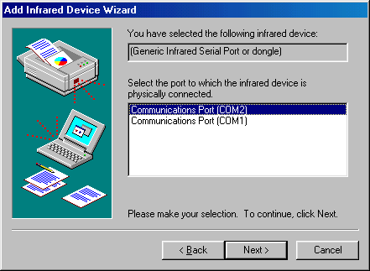
- Select the COM port to which the Infrared device is physically connected. In most cases, choose COM2. Click on “Next”.

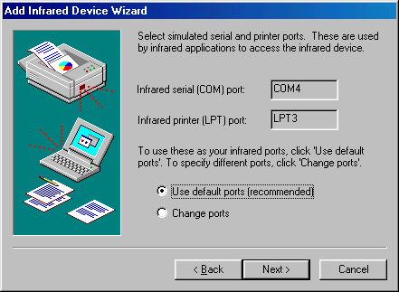
- Follow the screen prompts until it asks you what default ports to use. Select “Use default ports (recommended)”. Click on “Next”.

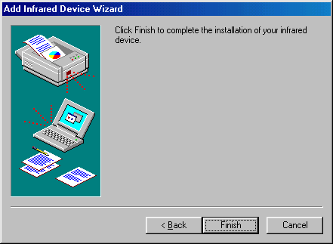
- Click on “Finish”, The driver is installed successfully.

- Please reboot your computer.

- Please refer to ACT-IR 200L/220L User’s Manual, “Setting Up” - Section B to continue installation.

(Ver.1.0, 8-31-98)

