Windows 98 IR setup for ACT-IR2000B + IR2000L(or IR2000LC)

Caution: Do not install Infrared Driver Ver 3.0 under Windows98, it will not work at all.

Connect ACT-IR2000L adapter to the Mini DIN 8 IrDA port of IR2000B. In PC BIOS, please disable COM2 (for IR2000B only).

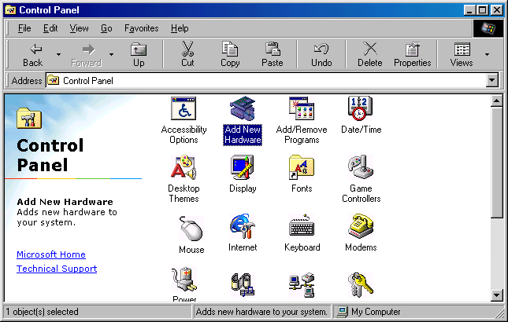
- Go to “Control Panel” and double
click on “Add New Hardware”.

- On the following screen, click on “Next” twice, then select “No, the device isn’t in the list”. And at the next screen, click on “Next”.

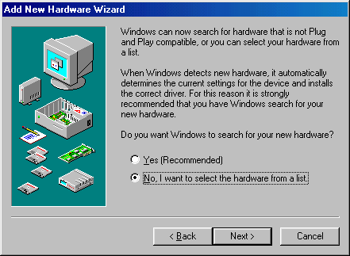
- Select “No I want to select
Hardware from the list”,

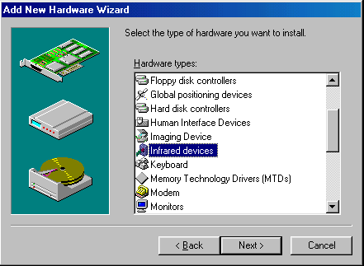
- Scroll down the menu and
highlight “Infrared Devices”,
then click on “Next” twice.

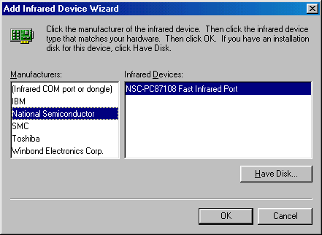
- Under “Manufacturers” Select
“(National Semiconductor)”,
and then in “Infrared Devices”
Select “(NSC-PC87108 Fast
Infrared Port)”.

Click on “OK”.

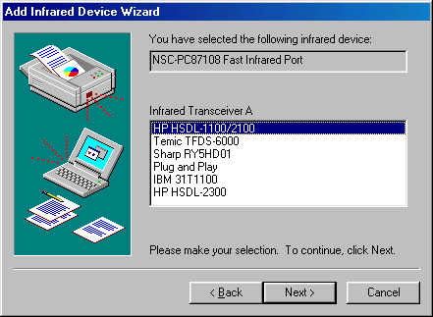
- At “Infrared Transceiver A”, Select “HP-HSDL-1100/2100”for IR2000L-PH,
IR2000LC-PH & IR2000L-HP*.
“Plug and Play”for IR2000L-PI,
IR2000LC-PI & IR2000L-IBM*.
Then click on “Next”.

At “Infrared Transceiver B”, Select
“None”. Then click on “Next”.
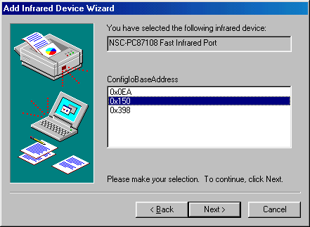
- At “ConfigIoBaseAddress”
Select “0x150”
Click on “Next”.

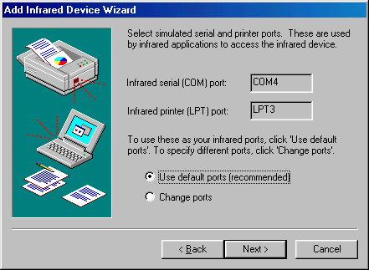
- Follow the screen prompts until it asks you what default ports to use. Select “Use default ports (recommended)”. Click on “Next”.

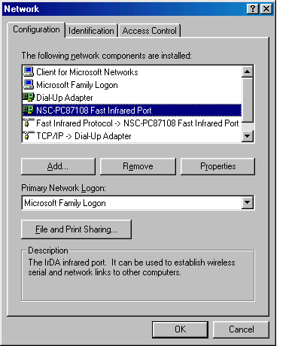
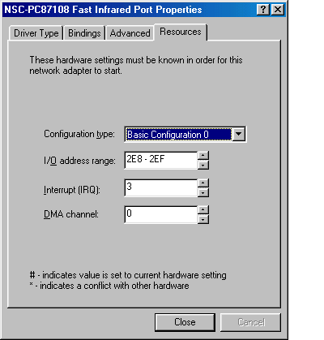
- When the process is completed, please go to “Control Panel” and double click on “Network”. Select “NSC-PC87108 Fast Infrared Port”. Click on “Properties”.

- In NSC-PC87108 Fast Infrared Port Properties Go to Resources and change I/O address range: 2E8-2EF,
IRQ: 3,
DMA: 0
Click “Close” and “OK”
Please reboot your computer.

- Please refer to ACT-IR 210L/2000L/2000B User’s Manual, “Page 13” to continue installation.

* Module type located on the shipping invoice.
(Ver.0.1, 9-03-98)

